LQR control
- Modern method of control
- Optimal control technique –
- uses Riccati equation for finding optimum feedback gain K
- K is found such a that Performance Index J is minimized
- 2 matrices – Q and R are selected by designer as per the specific requirement
1] Satellite control system –
Here, the need is to reduce the energy consumption as the system operates on Solar Power. In this case, we can keep high value for R and penalize the actuator efforts. However, this leads to degradation in performance. Ex, due to reduced power consumption, steady state error may increase.
2]Rocket control or missile control system
High accuracy is needed, so we can not compromise on performance. Hence, Large Q values are selected. This penalizes low performance, but with increased fuel consumption.

- This is full state feedback control technique.
- Block diagram of the pole placement and the LQR controller is same, However, different methods used to calculate the feedback gain K in both the cases.

Problem Statement- To implement LQR control for DC motor and verify results by choosing different value of Q and R.
Model
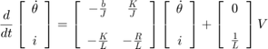
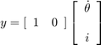

Parameters
(J) moment of inertia of the rotor 0.01 kg.m^2
(b) motor viscous friction constant 0.1 N.m.s
(Ke) electromotive force constant 0.01 V/rad/sec
(Kt) motor torque constant 0.01 N.m/Amp
(R) electric resistance 1 Ohm
(L) electric inductance 0.5 H

Matlab Code-
lqr(SYS,Q,R,N)close all;

% initialize state close all;
%
% initialize state
x0= [0.2; % 200 mA
0.0872] % rad/sec = 300 rpm

%motor dynamics
A = [-2 -0.02;
1 -0.01]

B = [2;
0]

C = [0 1]

D = [0]

Q = [1 0;
0 1]

R = [1]

%LQR command to find feeback gain K ()
K = lqr(A,B,Q,R);
% close loop system
SYS= ss(A-B*K,B,C,D);
% creating time stamps
t= 0: 0.005 : 30;
% stimulate the system
[y,t,x] = initial(SYS,x0,t);
plot (t,y);

Comparison of graph for different choices of values of Q and R matrices.

Case 1 With same weightage given to both performance and actuator efforts

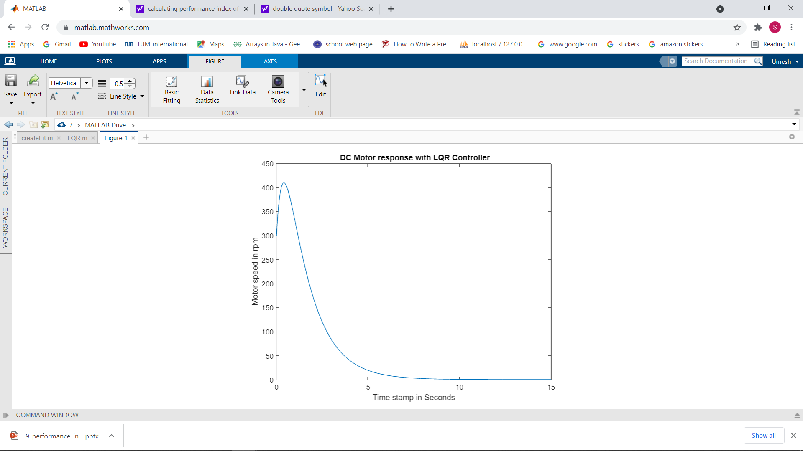

Case 2 Values of Q matrix are kept high while R = 1; system setles down quickly.

Q = [10 0
0 10]

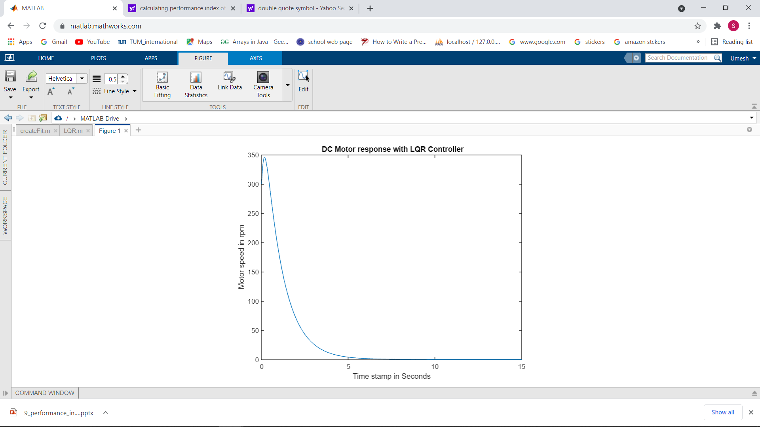
Case 3 Q = diagonal matrix with all values equals to 1 and R = 10, penalizing actuator efforts.
setting time is increased.

